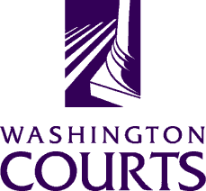

November 12, 2019

TO: Judges, Commissioners, County Clerks, Court Administrators, Libraries, Attorneys, and Public

FROM: Shannon Hinchcliffe, AOC Legal Services and Appellate Court Support Manager

SUBJECT: November 2019 Technical Change to GDN 04.0200

The Washington Pattern Forms Committee corrected a typographical error changing the word “duty” to “duly” on the first line under the caption of the form.

